Project 5

Scenario: You have been approached by the Walton College of Business to create a web application to display student transcripts, including their GPA, from grades stored in the Hog Country University database.

# Initial Web Application Setup

1. Web server space has been created for you at: <https://isys3393.walton.uark.edu/yourloginID>
2. Follow these steps to navigate to the correct directory and file to store your code:
   1. Login to the VMWare virtual desktop environment
   2. Open File Explorer and paste \\10.255.20.22\ into the address bar
   3. Double click your loginID folder
   4. You need to see file extensions in File Explorer, so click view from the top menu and check the box “File name extensions”
   5. If there are files “iisstart.htm” and “iisstart.png” in the directory, delete both files
   6. Download assignment files (razorback.svg, signin.css, and web.config) and copy them into the directory
   7. Create a new text file in this directory (right click open area in File Explorer, click “New”, click “Text Document”
   8. Rename the file “New Text Document.txt” to “default.aspx”
   9. Most of your code will be in the “default.aspx” file
   10. Double click the “deault.aspx” file and open it with Visual Studio 2015
   11. To test that everything is working, type “test” in the file and save  
       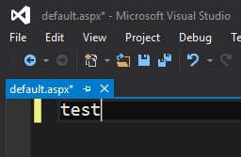
   12. Navigate to the URL in Chrome: <https://isys3393.walton.uark.edu/yourloginID> and you should see “test”  
       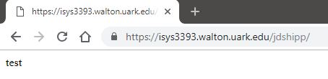
   13. If you see “test” in Chrome, then everything is working - go back to Visual Studio and delete the “test” text and save the file (default.aspx)

# Bootstrap Template Config

1. You will be using the Bootstrap library to help us quickly make a web application that looks good and is responsive (adapts to screen sizes / works on both bigger PC screens and smaller phone screens)
2. Follow these steps to add the basic Bootstrap template to your code (default.aspx):
   1. Navigate to <https://getbootstrap.com/>
   2. Click “Docs”
   3. Scroll down to section 2 of “Quick start” section of the web page and copy the html code  
      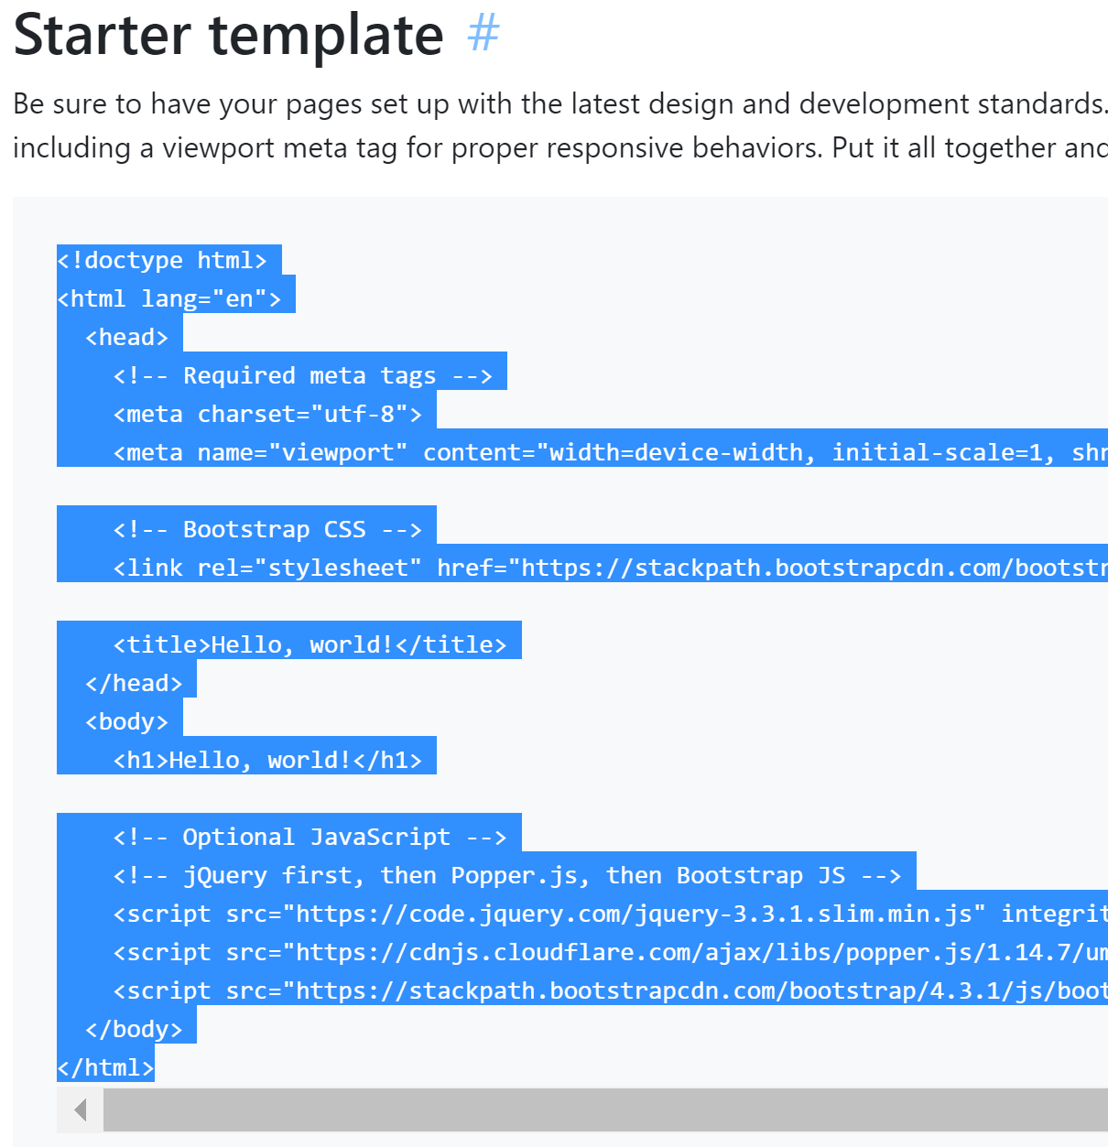
   4. Paste the code into your default.aspx file in Visual Studio (the file should be empty before you paste the code) and save
   5. Navigate to your website again and you should see “Hello, World!”
   6. Find the <title> tag in the HTML and change the text from  
      <title>Hello, world!</title> to <title>Hog Country Student Transcripts</title>
   7. Remove the “<h1>Hello, world!</h1>” line from the body.

# HTML

1. You need to consider what HTML components you will need for your web application:
   1. Dropdown list of students
   2. A button that will show the student’s transcript
   3. A grid to show the details of the transcript
2. Click on the “Examples” menu on the top of the Bootstrap web page to explore the options for your web application
3. You will need the following components:
   1. Main elements: Razorback Logo, “Select Student” text, and a button, when clicked, shows the selected student’s transcript.
      1. Most of these initial elements are contained in the “sign-in” custom component (found on the Bootstrap Examples web page)
      2. Click “sign-in”, then right click the web page and view source
      3. You will be using parts of this source in your web application:
         1. You are mainly concerned with the html between the <BODY> and </BODY> tags
         2. Copy and paste the body from the Boostrap example into your default.aspx body
         3. Be careful not to overwrite any part of your existing body  
            Do not overwrite anything below the line with: <!-- Optional JavaScript -->
         4. There should only be one beginning <BODY> tag and one ending </BODY> tag
         5. Verify the “text-center” class is in the <BODY> tag. Example: <body class=”text-center”>
         6. A reference to the signin.css stylesheet should be added at the end of the header: just above the </HEAD> tag: <link href="signin.css" rel="stylesheet">
         7. Change the image to show the razorback.svg picture instead of the Bootstrap Logo:
            1. On the line in the body that starts with <img, change the source image: src=”razorback.svg”
            2. Also change the width and height properties of the image from 72 to 100%
         8. On the next line, change the text “Please sign in” to “Select Student”
            1. At this point, your application should look similar to this:  
               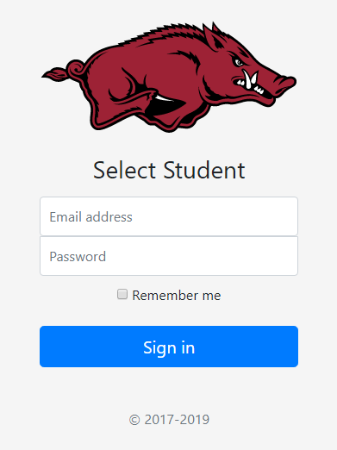  
               You have no need for the “Password” and “Remember me” components, and you need to change the “Email Address” textbox to a dropdown list that will contain the list of students (see below)
         9. To remove the unneeded components, delete the seven lines in your html that start with the label line for inputpassword and ends with the closing </div> tag for the checkbox
   2. A combobox / dropdown menu to select the student (different Bootstrap example)
      1. Use part of the “checkout” custom component (found on the Bootstrap Examples web page) for the select student functionality
      2. The “Country” dropdown looks like something you could use
      3. Click “checkout”, then right click the web page and view source
      4. Look for the HTML for the “Country” dropdown
         1. Find the <SELECT> component for country in the source html. Copy the 4 lines of html that start with <select and ends with the closing </select> tag for country.
         2. Paste these four lines into your source, overwriting the two label and input lines for email.
         3. Change the id of the select components from id=”country” to id=”studentid”
         4. Add “form-control” and “mb-3” to the class properties of the select component
         5. The class property for the select component should be similar to:   
            class="form-control mb-3 custom-select d-block w-100"
         6. Change the second option from <option>United States</option> to:  
            <option value="0">Frank Broyles</option>
         7. Change the text “Sign in” for the button to “Show Transcript”
         8. At this point, your application should look similar to this:  
            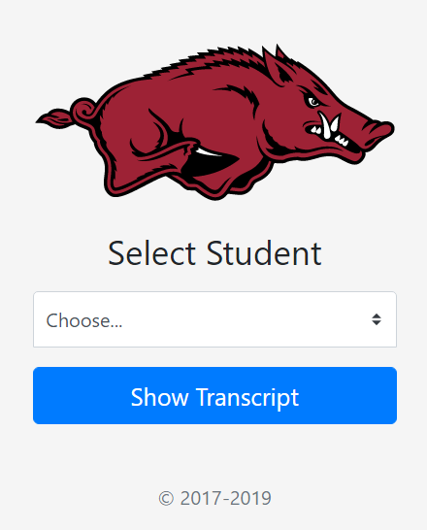
   3. A table or grid that displays the student’s terms and grades after they have clicked the show transcript button
      1. A table may be the best component to display this information
      2. Check here for Bootstrap table information: <https://www.w3schools.com/bootstrap/bootstrap_tables.asp>
      3. Scroll down to the “striped row” section and click “Try it yourself”
      4. Now you can see the html that generates the example table, and you are mainly concerned with the table element of this html
      5. Copy the html from the beginning table tag to the ending table tag and paste it under the </form> tag in the body
      6. The application should look similar to:  
         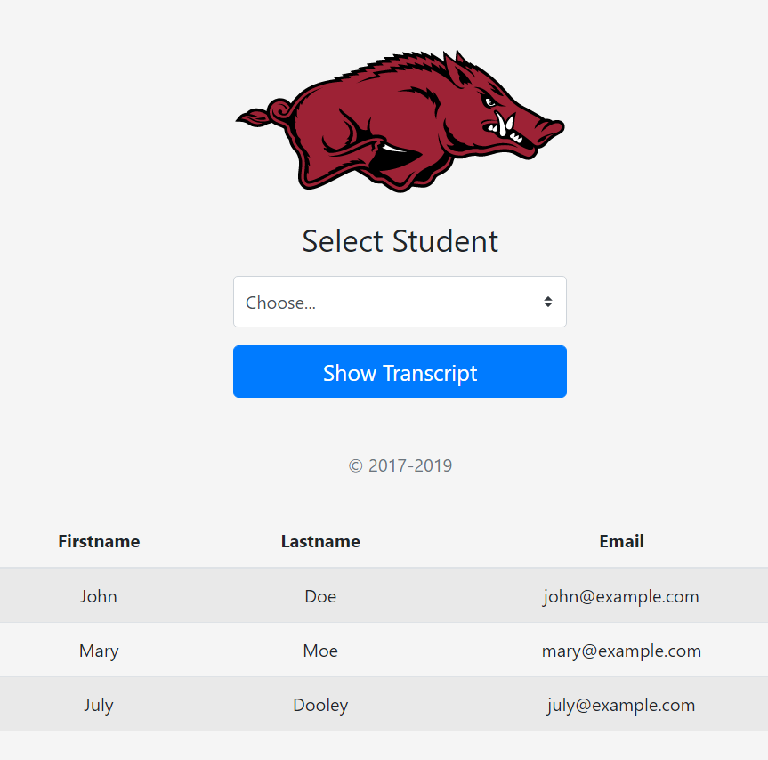
      7. You want to make table header records for: Term, Course, Hours, and Grade
         1. With the example, you only have three fields and they have incorrect information
         2. The <thead> tag indicates a table header
         3. The <tr> tag indicates a table row
         4. The <th> tag indicates the text for the table field header
         5. “Firstname” should be changed to “Term”
         6. “Lastname” should be changed to “Course”
         7. “Email” should be changed to “Hours”
         8. And you need to add a new field / header for grade:
            1. <th>Grade</th> beneath the Email table header html
            2. This should look similar to:  
               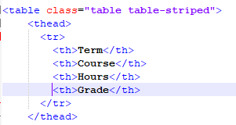
      8. All classes will be three hours for simplicity (consider later for GPA calculation)
      9. The example code only consists of three fields, and you need your web application to show the four fields mentioned above
         1. You have four table headers, but you need to change your table body / rows to contain the four fields
         2. The <tbody> tag indicates the body (rows) of the table
         3. There are three records in the example from w3schools
         4. Change the existing example data to make sense in this context:
            1. In the first table row for the table body, change:

“John” to “Spring 2019”

“Doe” to “Intro to Razorback Football”

“[john@example.com](mailto:john@example.com)” to “3”

Add line: <td>A</td>

* + - * 1. Change the remaining two table row / table data records to reflect the following information:

“Spring 2019” for both term records

“Intro to Razorback Football” and “Intro to Razorback Baseball” for course records

“3” and “3” for the hours records

“B” and “C” for the grade records

* + - * 1. Your application should look similar to:  
           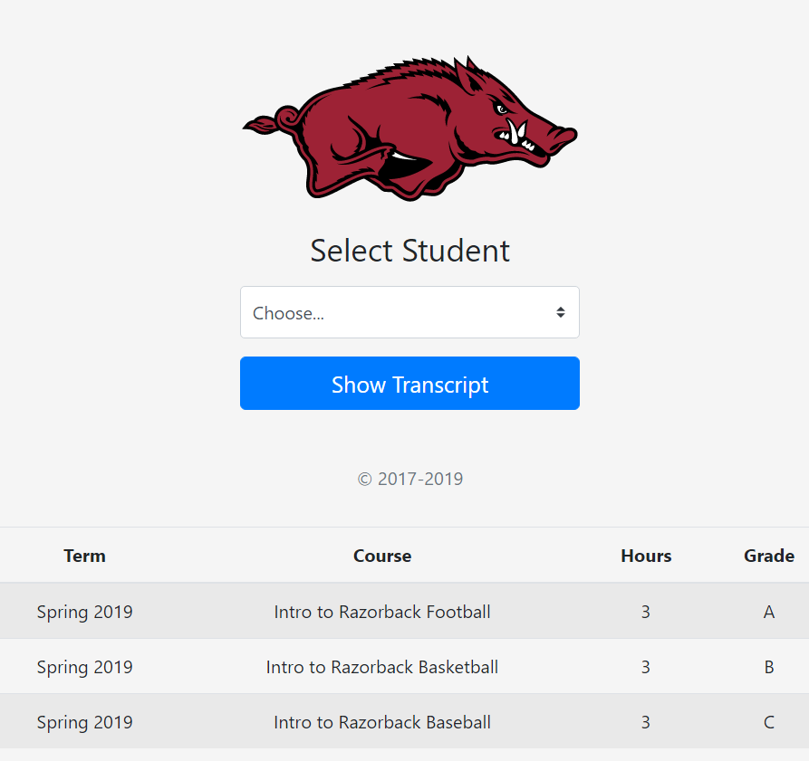
    1. To this point, you have been working with HTML only to build a static web page (displayed information does not change). You will use C# to use data from the database to display transcript information about the student selected – a dynamic web page (displayed information changes).
  1. You need to calculate the GPA from the grades for the selected student in the database and display it at the bottom of the transcript
     1. Assume all classes are worth 3 hours
     2. GPA is calculated: Total Grade Points / Total Credit Hours
     3. Grade Points are calculated using the grade scale A=4, B=3, C=2, D=1, F=0 and multiplying the grade by the credit hours for the class
     4. In class you will learn how to make a method to connect to the database and calculate the GPA

# Code

1. Up to this point, you have only been dealing with HTML, CSS, and JavaScript with Bootstrap.
2. To use C# code in the web application, you need to add the following code to the very top of the default.aspx file:

<%@ Page Language="C#" Debug="true" %>

<%@ Import Namespace="System.Data.SqlClient" %>

<%@ Import Namespace="System.Data" %>

<script language="C#" runat="server">

int SampleGlobalVariable = 0;

public void Page_Load(object sender, EventArgs e)

{

// Page Load Code

}

private void SampleMethod()

{

}

</script>

1. This C# code with be used to manipulate / generate HTML for your web application
2. Some of the Walton_DB code will need to be used. You will not include the entire file – only the few methods you need to fill a datatable.
3. The following code can be added before the C# </script> area near the top of the default.aspx file:

// Database Code Below This Line

// #############################

private static bool FillDataTable_ViaSql(ref DataTable ReturnTable, string SqlStr)

{

SqlCommand SqlCmd = new SqlCommand(SqlStr);

return FillDataTable_ViaCmd(ref ReturnTable, ref SqlCmd);

}

private static bool FillDataTable_ViaCmd(ref DataTable ReturnTable, ref SqlCommand SqlCmd)

{

System.Data.SqlClient.SqlDataAdapter lo_Ada = new System.Data.SqlClient.SqlDataAdapter();

DataTable Return_DataTable = new DataTable();

SqlConnection ActiveConn;

if (!OpenConnection())

return false;

else

ActiveConn = lo_Connection;

SqlCmd.Connection = ActiveConn;

SqlCmd.CommandTimeout = CommandTimeOutSeconds;

int Retry = 2;

while (Retry >= 0)

{

try

{

lo_Ada.SelectCommand = SqlCmd;

lo_Ada.Fill(Return_DataTable);

lo_Ada.Dispose();

lo_Ada = null;

ActiveConn.Close();

ReturnTable = Return_DataTable;

return true;

}

catch (Exception ex)

{

if (Retry >= 1 && ex.Message.Contains("deadlock victim"))

{

System.Threading.Thread.Sleep(3337);

Retry -= 1;

}

else if (Retry >= 1 && (ex.Message.Contains("INSERT EXEC failed ") || ex.Message.Contains("Schema changed ")))

{

System.Threading.Thread.Sleep(3337);

Retry -= 1;

}

else

{

ActiveConn.Close();

Retry = -1;

}

}

}

return false;

}

private static SqlConnection lo_Connection;

private const int CommandTimeOutSeconds = 1200;

private static bool OpenConnection()

{

int Retry = 2;

while (Retry >= 0)

{

try

{

if (lo_Connection == null)

{

lo_Connection = new SqlConnection();

lo_Connection.ConnectionString = "Data Source=msenterprise.waltoncollege.uark.edu;Initial Catalog=<database>;user id=<user>;password=<password>;Persist Security Info=False;";

}

if (lo_Connection.State == ConnectionState.Closed)

lo_Connection.Open();

return true;

}

catch (Exception ex)

{

lo_Connection.Dispose();

lo_Connection = null;

if (Retry >= 1 && (ex.Message.Contains("Data Provider error 6") || ex.Message.Contains("An existing connection was forcibly closed") || ex.Message.Contains("The specified network name is no longer available") || ex.Message.Contains("The semaphore timeout period has expired") || ex.Message.Contains("The timeout period elapsed prior to completion of the operation")))

{

// short pause before retrying

System.Threading.Thread.Sleep(1337);

Retry -= 1;

}

else if (Retry >= 1 && (ex.Message.Contains("The server was not found or was not accessible")

|| ex.Message.Contains("Could not open a connection to SQL Server")))

{

// long pause before retrying

System.Threading.Thread.Sleep(91337);

Retry -= 1;

}

else

Retry = -1;

}

}

return false;

}

1. The above code is the minimal amount of code you need to talk to the database
2. The connection string will need to be changed again (database, login ID, and Password) – refer to the Project 4 instructions for more information
3. You will connect to the production database for this application
4. The C# code needed to complete this project will be demonstrated in class.

# SQL

1. SQL to populate student dropdown:  
   SELECT StudentID, StudentName FROM tbl_Students Order By StudentName
2. SQL to display transcript (and other info):  
   SELECT tbl_Terms.Term, tbl_Students.StudentName, tbl_Colleges.College, tbl_Majors.Major, tbl_Courses.Course, tbl_Grades.Grade FROM tbl_Grades INNER JOIN tbl_Courses ON tbl_Grades.Course = tbl_Courses.CourseID INNER JOIN tbl_Students ON tbl_Grades.Student = tbl_Students.StudentID INNER JOIN tbl_Terms ON tbl_Grades.Term = tbl_Terms.TermID INNER JOIN tbl_Colleges ON tbl_Students.StudentCollege = tbl_Colleges.CollegeID INNER JOIN tbl_Majors ON tbl_Students.StudentMajor = tbl_Majors.MajorID WHERE (tbl_Grades.Student = " + StudentID + ") ORDER BY tbl_Terms.Term, tbl_Courses.Course
3. SQL to display student’s name above transcript:  
   SELECT StudentName FROM tbl_Students WHERE (StudentID = " + StudentID + ")

# Rubric

1. Submission of your zipped default.aspx file (5 points)
2. Student Selection / Password screen functional (10 points)
3. Transcript Display functional (10 points)
4. 12 more grades entered (4 for Spring 2018, 4 for Fall 2018, and 4 for Fall of 2019) for yourself into the Hog Country Students **Production** Database using your Project 4 code, or the Project 4 Demo (5 points)
5. Your accurate GPA displayed at bottom of transcript (10 points)
6. Bonus points at instructor’s discretion – Please include in your submission a description of potential bonus work